PYTHON LEARNING PLATFORM
A GUI-Based Python Learning Desktop Application

A Project Report Submitted by
SHAIK SHAHEDA
ENROLLMENT NO : 92500116016
ATHOTA GIRISH CHOWDARY
ENROLLMENT NO : 92500116008

in partial fulfillment for the award of the degree of
Bachelor of Technology
In
Computer Engineering-AI, ML & DS (P.B.L.)
Faculty of Engineering & Technology
Marwadi University, Rajkot
2025-26

Faculty of Engineering & Technology
Marwadi University
Department of Computer Science & Engineering – AI, ML & DS (P.B.L.)
2025-26

CERTIFICATE
This is to certify that the project entitled “Python Learning Platform — A GUI-Based Python Learning Desktop Application” has been carried out by Shaik Shaheda (Enrollment No. 92500116016) and Athota Girish Chowdary (Enrollment No. 92500116008) as a group project, under my guidance, in partial fulfillment of the degree of Bachelor of Technology in Computer Engineering – AI, ML & DS (P.B.L.) of Marwadi University, Rajkot during the academic year 2025-26.

Date: ____________________

Internal Guide | Head of the Department
Mukhtar Sama  Assistant Professor | Dr. Nilesh Kumar Jadav  Head & Associate Professor

STUDENT DECLARATION
We, Shaik Shaheda (Enrollment No. 92500116016) and Athota Girish Chowdary (Enrollment No. 92500116008), hereby declare that this project report titled “Python Learning Platform — A GUI-Based Python Learning Desktop Application” is our own group work, prepared under the guidance of Mukhtar Sama as part of the Programming with Python (01AP0303) course at Marwadi University.
We understand every screen, function, and content structure included in this submission, and we are able to explain and, if required, modify or execute any part of the code during the viva voce examination. Wherever ideas, code fragments, libraries, APIs, or learning material from external sources (including AI-assisted tools) have been used, they have been acknowledged in the References section of this report.

Signature (Shaik Shaheda): _______________________ Date: _______________
Signature (Athota Girish Chowdary): _______________________ Date: _______________

ACKNOWLEDGEMENT
The successful completion of this project would not have been possible without the support, guidance, and encouragement of a number of people, and we take this opportunity to express our sincere thanks to each of them.
First and foremost, we would like to express our heartfelt gratitude to our faculty guide, Mukhtar Sama, for the continuous guidance, patient mentorship, and constructive feedback provided at every stage of this project — from the initial planning of the module structure to the final review of the working application. Their suggestions on organising the learning content, structuring the quiz logic, and keeping the user interface consistent helped us significantly improve the quality of our work, and their willingness to clarify doubts and review our progress regularly kept the project on track.
We are equally grateful to the Department of Computer Science & Engineering – AI, ML & DS (P.B.L.), Marwadi University, for providing us with the resources, laboratory access, and a structured learning environment that made this project possible. The Programming with Python (01AP0303) course curriculum gave us the conceptual foundation — covering variables, control flow, functions, data structures, and object-oriented programming — that we were able to directly apply while designing and coding this platform.
We would also like to thank our fellow classmates and peers, with whom we had many useful discussions while debugging Tkinter layout issues and refining the flow of the application; their observations as test users of the early versions of the platform helped us identify and fix several usability issues before final submission.
Finally, we acknowledge the official Python and Tkinter documentation, which served as our primary technical reference throughout development, as listed in the References section. We also thank our families for their constant encouragement and support throughout the duration of this project.

ABSTRACT
This project presents the design and implementation of “Python Learning Platform”, a single-file, GUI-driven Python learning application built entirely using Python’s standard Tkinter toolkit. The platform addresses a common difficulty faced by beginner programmers: scattered learning material that separates theory from self-assessment. Python Learning Platform instead organises learning into seven structured modules — Python Fundamentals, Control Flow and Functions, Data Structures, File and Exception Handling, Object-Oriented Programming, Database and Web, and Automation and Projects — covering a combined 68 topics, each presented as a block of detailed theory text with runnable code fragments shown as examples within that text.
The application uses a single Tkinter class, LearningPlatform, that both builds every screen (Login, Get Started, Dashboard, Module/Topic view, Quiz, Result, and Certificate) and holds the learner’s progress as in-memory instance variables. Access is controlled by a single hardcoded username and password pair rather than a registration system. Learners move through each module’s topics in order, attempt a 5-question auto-graded quiz per module, and can only unlock the next module after completing the current one. After all seven modules are finished, a 5-question Final Quiz and a 5-question Final Assessment are presented, after which a Certificate screen displays the learner’s combined score out of 45 marks and a percentage.
Because the application keeps all content and progress in Python data structures rather than a file or database, progress resets whenever the application restarts, and the certificate is a Tkinter screen rather than a saved file. The result is a compact, self-contained, single-file teaching tool that demonstrates variables, control flow, functions and lambda expressions, core data structures (lists, dictionaries, tuples), string formatting, and event-driven GUI programming with Tkinter — all applied directly in the code that builds the platform itself.

INDEX
(This index lists report sections in order. Page numbers should be added/updated in Word after final formatting — use References → Table of Contents, or update manually before submission.)
- 1. Introduction
- 2. Problem Statement and Objectives
- 3. Requirement Analysis
- 4. Proposed Design
- 5. Tools and Concepts Used
- 6. Implementation
- 7. Testing and Debugging
- 8. Results and Discussion
- 9. Conclusion and Future Scope
- References

LIST OF FIGURES
Figure | Title
Figure 1 | Project Workflow Flowchart
Figure 2 | System Architecture / Block Diagram
Figure 3 | Input-Process-Output (IPO) Diagram
Figure 4 | Content & Application-State Data Model
Figure 5 | Class Diagram — LearningPlatform
Figure 6 | User Interface Wireframes (Login and Dashboard)
Figure 7 | Use Case Diagram

LIST OF TABLES
Table | Title
Table 1 | Module and Topic Summary
Table 2 | Functional Test Cases

1. INTRODUCTION
Learning a programming language such as Python is often made harder than it needs to be by scattered resources: theory on one website, examples on another, and no single place to measure how much has actually been understood. Beginners frequently lose track of their own progress or attempt advanced material without practicing the basics first.
This project, “Python Learning Platform”, was undertaken as a group project for the Programming with Python (01AP0303) course. It is a self-contained, single-file desktop application built using Python’s built-in Tkinter GUI toolkit, that organises structured theory, embedded code examples, and auto-graded quizzes into one coherent learning journey covering seven Python modules.

1.1 Target Learner Profile
The platform is designed for a beginner learner — typically a first- or second-year engineering student — who has basic computer literacy but is new to Python and to structured programming concepts such as control flow, data structures, object-oriented programming, and databases. The learner needs a desktop or laptop computer with Python 3.8 or later installed, but no prior programming experience.

1.2 Motivation
The motivation for this project came from a common learning gap: most free tutorials present isolated snippets of theory without any built-in way to test understanding immediately afterward. By combining structured theory with a per-module quiz and a visible module-by-module unlocking sequence, the platform gives a learner a clear, linear path through the syllabus and an immediate sense of whether a module has actually been understood before moving on.

2. PROBLEM STATEMENT AND OBJECTIVES

2.1 Problem Statement
Beginner Python learners often lack a single, self-contained application that presents topic-wise theory together with an immediate, auto-graded check of understanding — forcing them to piece together learning material from disconnected sources with no structured, sequential path through the syllabus.

2.2 Objectives
- To design and implement a GUI-based learning application covering all seven core areas of Python: fundamentals, control flow and functions, data structures, file and exception handling, object-oriented programming, database and web concepts, and automation/project practices.
- To provide, for every topic, a structured block of theory text that includes an illustrative code example, so the concept is explained and demonstrated together.
- To implement a 5-question auto-graded quiz per module, so a learner’s understanding of that module is checked before the next module is unlocked.
- To enforce a sequential learning path, where a module (and its topics) can only be opened once the previous module and its quiz are completed.
- To provide a combined Final Quiz and Final Assessment once all seven modules are complete, giving a broader check across the full syllabus.
- To display a summary Certificate screen showing the learner’s combined score across all quizzes and the resulting percentage.

3. REQUIREMENT ANALYSIS

3.1 Functional Requirements
- The system shall authenticate a learner using a fixed username and password before granting access to any content.
- The system shall display seven learning modules, each containing multiple topics presented as theory text with an embedded code example.
- The system shall allow the learner to move sequentially through the topics of the current module using a “Next Step” control.
- The system shall present a 5-question, single-best-answer quiz at the end of each module and compute a score out of 5.
- The system shall prevent a learner from opening a module before the previous module (and its quiz) has been completed.
- The system shall present a 5-question Final Quiz and a 5-question Final Assessment once all seven modules are completed.
- The system shall display a Certificate screen showing the combined score out of 45 marks and the resulting percentage.
- The system shall warn the learner if they attempt to submit a quiz question without selecting an answer.

3.2 Non-Functional Requirements
- Usability: the interface shall use a single, consistent dark-blue colour theme and font family across every screen.
- Responsiveness: the application window shall open maximized and remain resizable.
- Portability: the application shall run on any platform with Python 3.8+ and Tkinter installed — no third-party libraries or network connection are required.
- Simplicity: the entire application shall be implemented as a single Python file, keeping the module content, quiz data, and UI logic together for easy review.

3.3 Software and Hardware Requirements
Category | Requirement
Operating System | Windows / macOS / Linux (any OS supporting Python 3.8+)
Language | Python 3.8 or later (developed and tested on Python 3.12)
Libraries | tkinter, datetime — both part of the Python standard library
IDE | Visual Studio Code (or any text editor/IDE)
Hardware | Any standard desktop or laptop capable of running Python 3.8+

3.4 Input-Process-Output (IPO) Analysis
The overall Input-Process-Output relationship of the system is summarised below and illustrated in Figure 3 (Section 4).
- Input: login credentials, topic navigation clicks, module selection clicks, and quiz-option selections.
- Process: credential matching, sequential module/topic unlock checks, quiz-answer comparison and scoring, and total score/percentage computation.
- Output: the dashboard with progress highlighting, rendered topic theory, quiz result screens, and the final certificate screen.

4. PROPOSED DESIGN
This section presents the workflow, architecture, data, and interface design of the Python Learning Platform through seven diagrams, each drawn specifically for this project to match the implemented code.

4.1 Project Workflow Flowchart
Figure 1 illustrates the complete user journey through the application, from launch to certificate, including the login-retry branch and the module-unlock decision points.
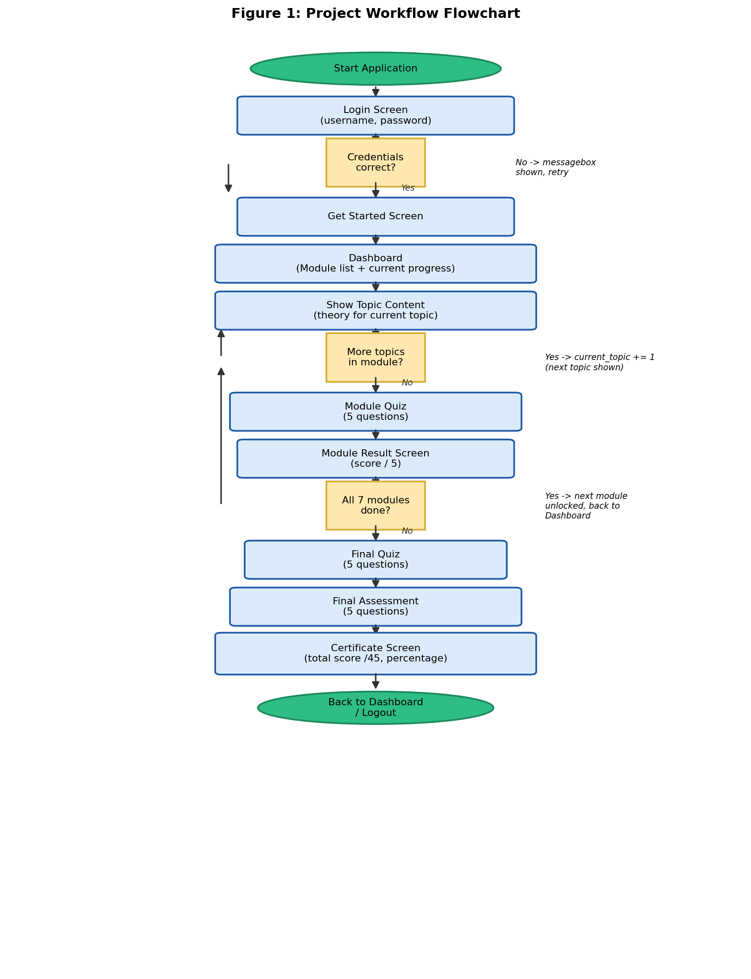
Figure 1: Project Workflow Flowchart

4.2 System Architecture / Block Diagram
Figure 2 shows the three logical layers used within the single Python file: a Tkinter presentation layer (all screens), an application/control logic layer (navigation, unlock rules, and scoring, implemented as methods of the LearningPlatform class), and a static, in-memory content data layer (the MODULES, MODULE_QUIZZES, FINAL_QUIZ, and ASSESSMENT constants). There is no database, file storage, or network layer.
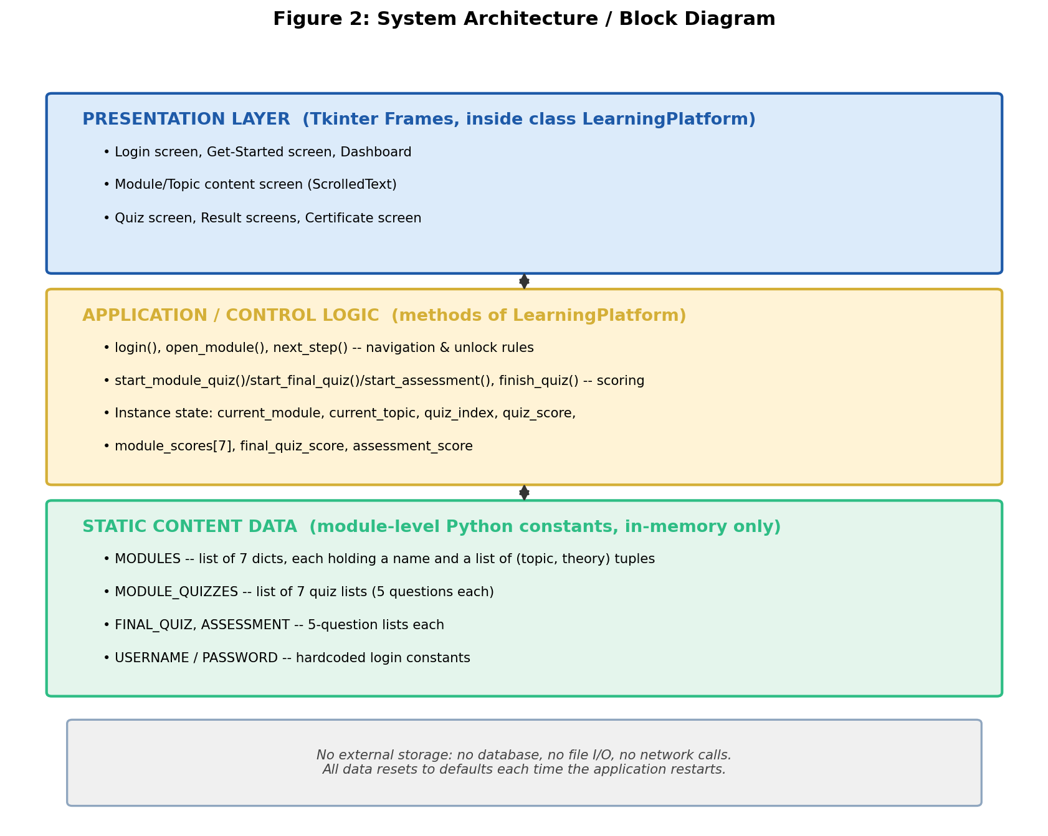
Figure 2: System Architecture / Block Diagram

4.3 Input-Process-Output Diagram
Figure 3 summarises the IPO analysis from Section 3.4 in diagram form.
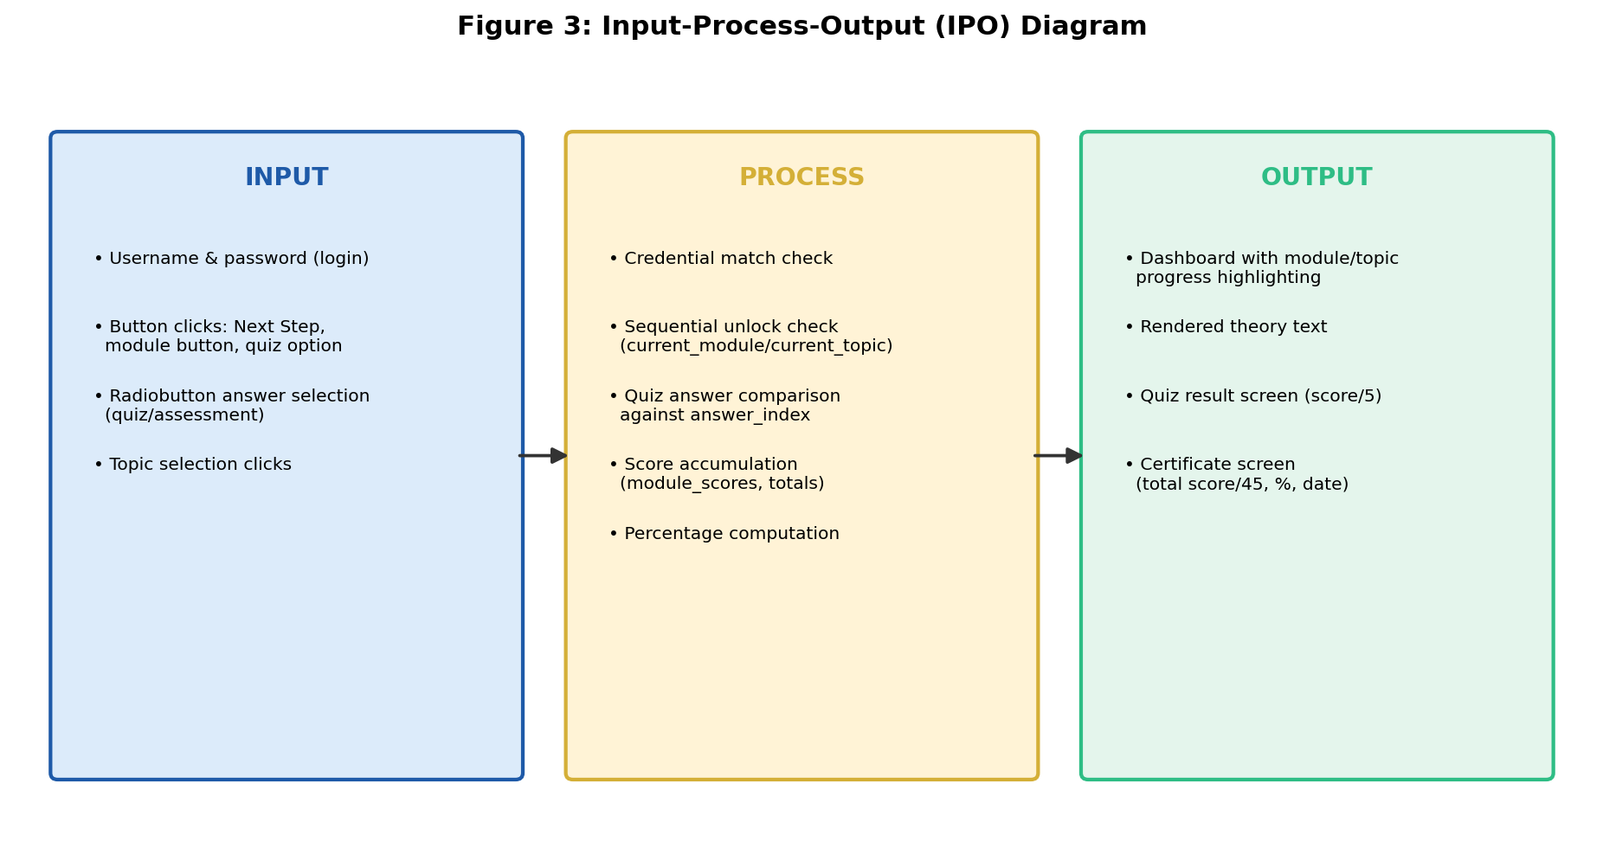
Figure 3: Input-Process-Output Diagram

4.4 Content and Application-State Data Model
Because the application has no database, Figure 4 shows the equivalent structure for this project: how the module content constants (MODULES, MODULE_QUIZZES, FINAL_QUIZ, ASSESSMENT) relate to the learner’s in-memory progress state, and how that state is combined to compute the certificate score.
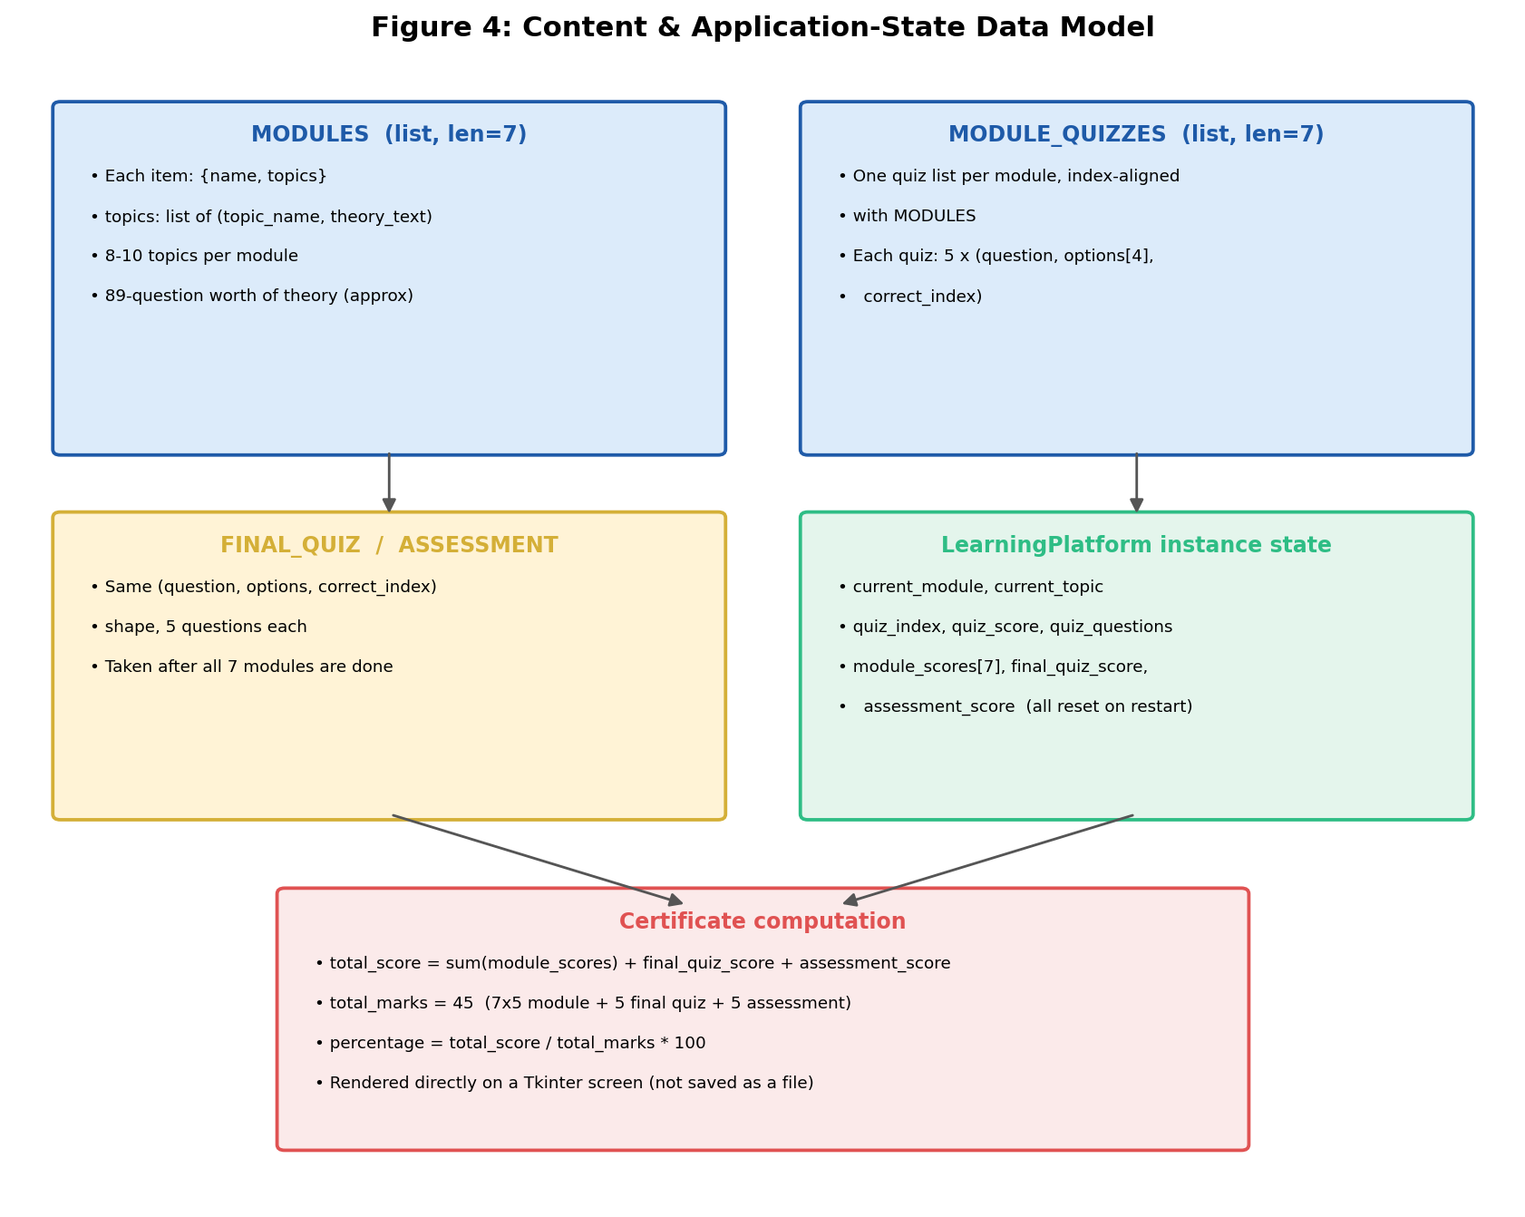
Figure 4: Content & Application-State Data Model

4.5 Class Diagram
The application is built around a single class, LearningPlatform, which both constructs every screen and holds all progress-tracking state. Figure 5 shows its main attributes and methods.
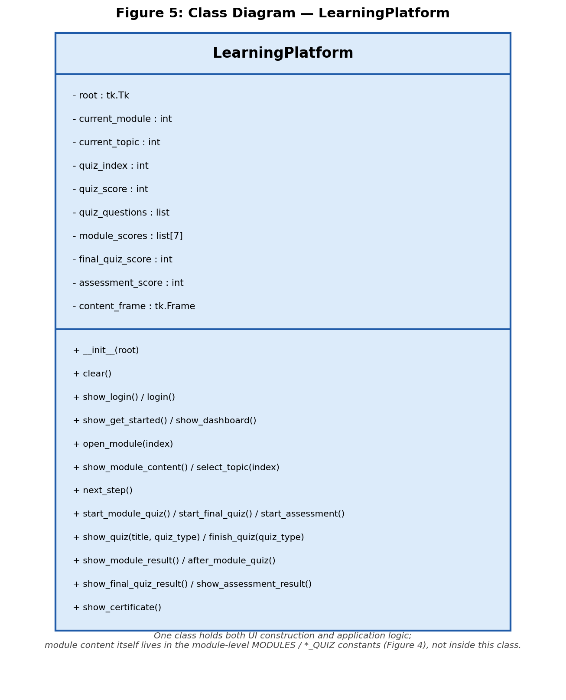
Figure 5: Class Diagram — LearningPlatform

4.6 User Interface Wireframes
Figure 6 shows simplified wireframes of two representative screens: the Login screen and the Dashboard/Module content screen, both matching the actual Tkinter layout, colours, and widget placement implemented in the code.
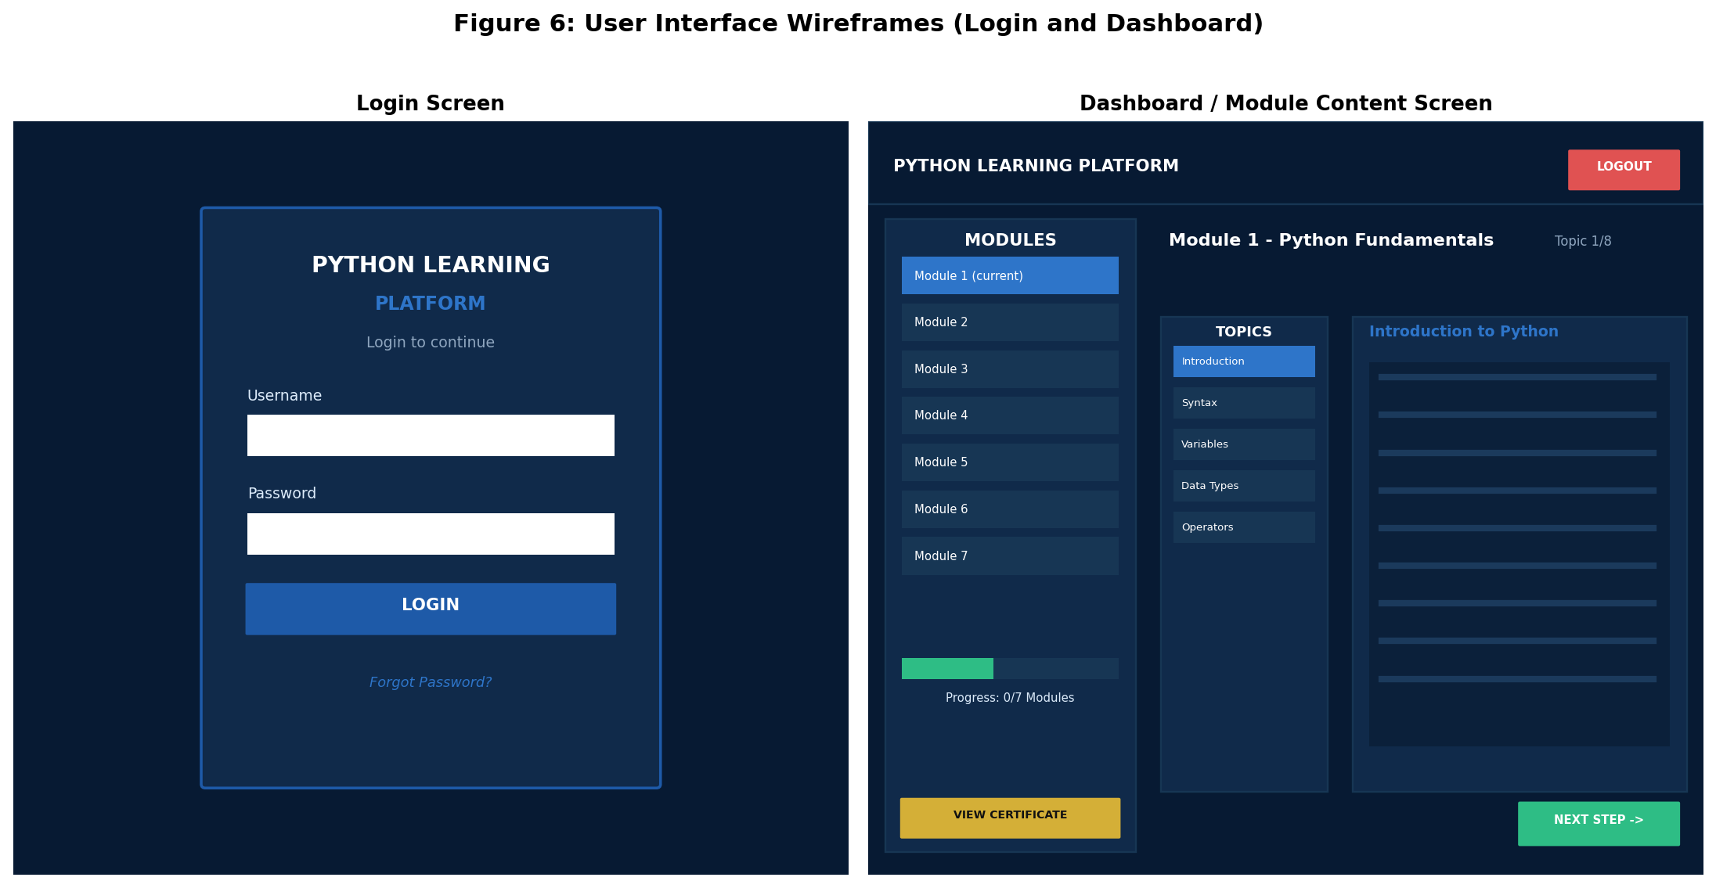
Figure 6: User Interface Wireframes (Login and Dashboard)

4.7 Use Case Diagram
Figure 7 shows the primary actor (the Learner) and the main actions available to them across the platform.
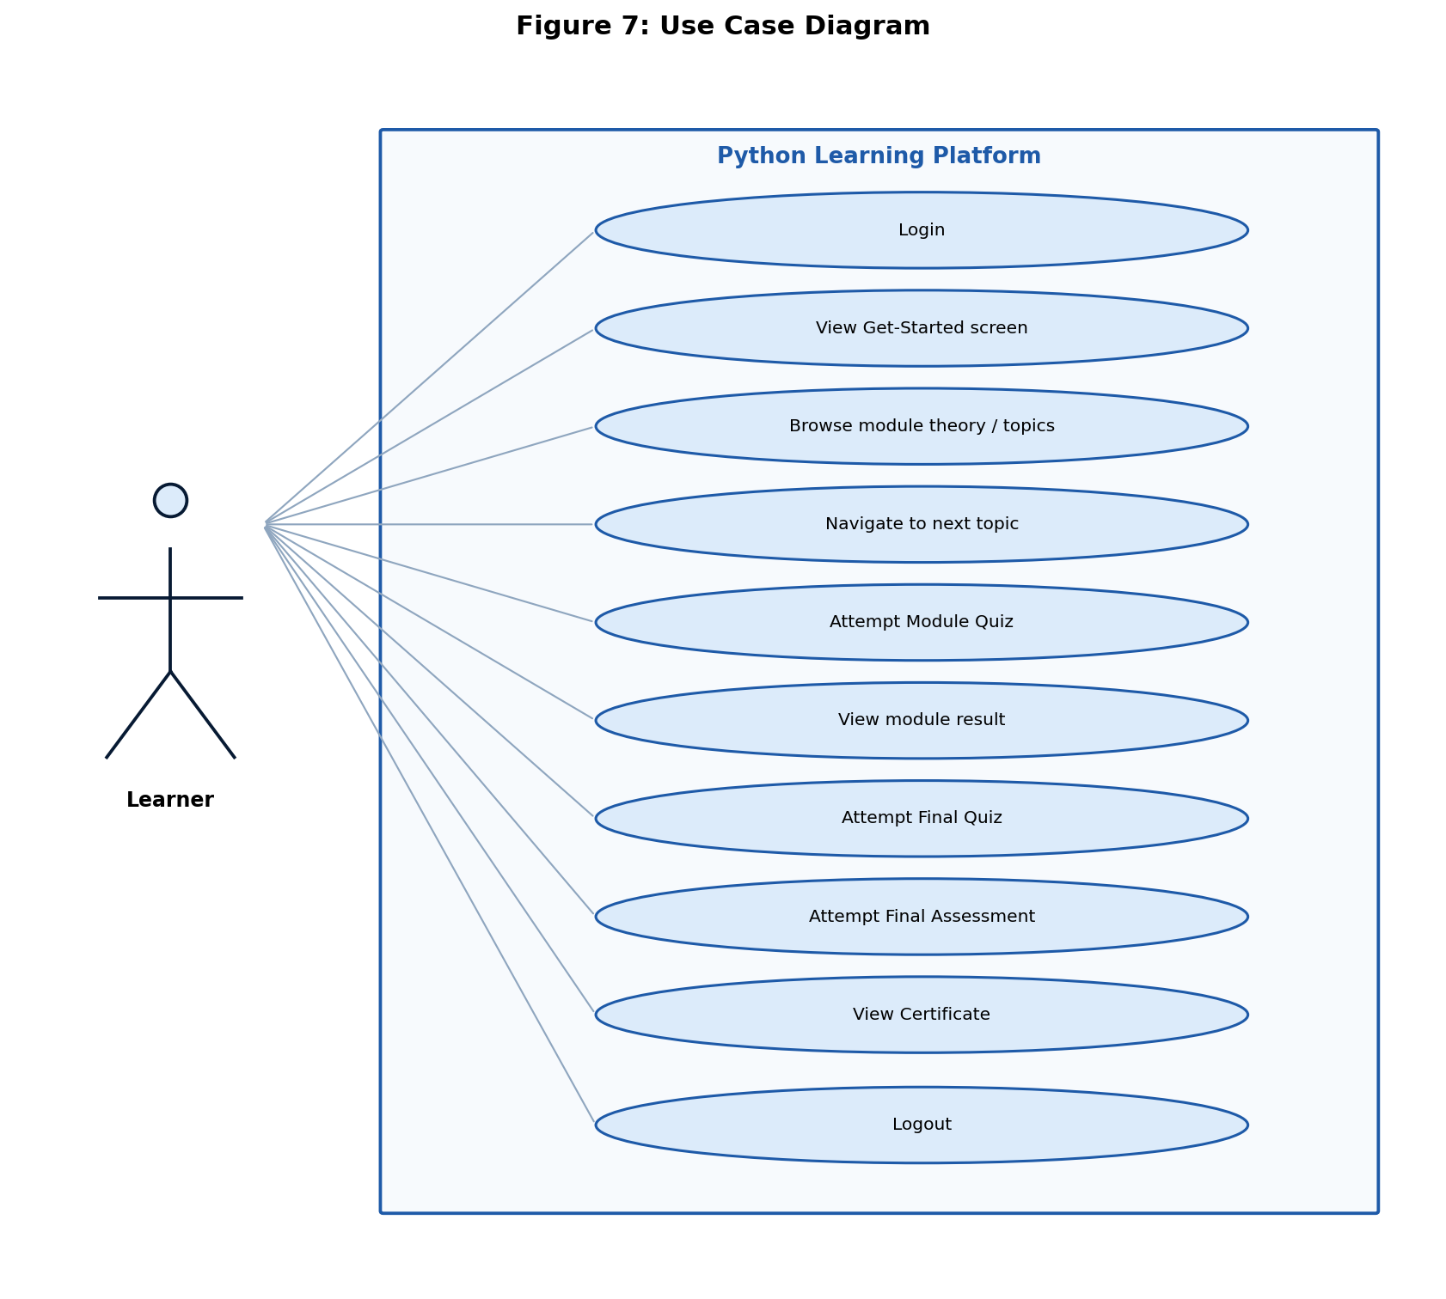
Figure 7: Use Case Diagram

5. TOOLS AND CONCEPTS USED

5.1 Development Environment
- Language: Python 3.12
- IDE: Visual Studio Code
- GUI Toolkit: Tkinter (standard library — tk, messagebox, scrolledtext)
- Date/Time: datetime (standard library, used for the certificate date)
- No third-party packages, database engine, or network library are used.

5.2 Core Python Concepts Demonstrated
The concepts below are the ones actually used to build the platform itself. Note that some topics taught inside the app’s theory content — such as file handling, database connectivity, and REST APIs — are explained as text and code examples for the learner to read, but are not used to construct the application itself, since the app has no file storage, database, or network access of its own.
- Variables, data types, and string formatting (f-strings) — used throughout the UI code and score displays.
- Control flow (if/elif/else, for loops) — used in login checking, sequential unlock logic, and building the module/topic button lists.
- Functions and methods — the LearningPlatform class is organised into over twenty single-purpose methods (login(), next_step(), finish_quiz(), etc.).
- Lambda expressions — used as Tkinter button callbacks that need to capture a loop variable, e.g. command=lambda index=i: self.open_module(index).
- Data structures (lists, dictionaries, tuples) — MODULES is a list of dictionaries; each topic is a tuple; each quiz question is a (question, options, correct_index) tuple.
- Object-oriented programming — the entire application is encapsulated in one class, LearningPlatform, whose constructor initialises state and whose methods both build and update the UI.
- Event-driven GUI programming — Tkinter widgets (Button, Radiobutton, ScrolledText) and the command/bind mechanisms drive every screen transition.

5.3 Module and Topic Summary
Module | Topic Count | Quiz Questions
1. Python Fundamentals | 8 | 5
2. Control Flow and Functions | 10 | 5
3. Data Structures | 10 | 5
4. File and Exception Handling | 10 | 5
5. Object-Oriented Programming | 10 | 5
6. Database and Web | 10 | 5
7. Automation and Projects | 10 | 5
Final Quiz | — | 5
Final Assessment | — | 5
Total | 68 topics | 45 questions

6. IMPLEMENTATION
The complete source code is submitted separately as a single editable .py file. This section explains the purpose of each major part of that file and highlights representative code listings; the full module content dictionaries are not reproduced here since they are very long.

6.1 Project File Overview
Unlike a multi-file application, this project is implemented entirely in one Python script, organised top to bottom as: colour constants, the MODULES content list, the MODULE_QUIZZES / FINAL_QUIZ / ASSESSMENT quiz data, and the LearningPlatform class containing every screen-building and logic method, followed by the standard if __name__ == "__main__": launch block.

6.2 Login Authentication
Access is controlled by comparing the entered username and password against two hardcoded constants. This is a simple, single-user gate rather than a real authentication system:
USERNAME = "shannu"
PASSWORD = "123456"

def login(self):
username = self.username_entry.get().strip()
password = self.password_entry.get().strip()

if username == USERNAME and password == PASSWORD:
self.root.unbind("<Return>")
self.show_get_started()
else:
messagebox.showerror("Login Failed", "Incorrect username or password.")

6.3 Module and Topic Content Structure
Every module is a dictionary with a name and a list of (topic_name, theory) tuples. This keeps all learning content as plain Python data rather than in external files:
MODULES = [
{
"name": "Module 1 - Python Fundamentals",
"topics": [
("Introduction to Python", """Python is a high-level ..."""),
("Python Syntax", """Python syntax refers to ..."""),
# ... 6 more topics
]
},
# ... 6 more modules
]

6.4 Sequential Module Unlocking
A module can only be opened if its index is not ahead of the learner’s current progress. Attempting to skip ahead shows a message instead of opening the module:
def open_module(self, index):
if index > self.current_module:
messagebox.showinfo("Module Locked",
"Complete the previous module and quiz first.")
return
self.current_module = index
self.current_topic = 0
self.show_dashboard()

6.5 Quiz Auto-Grading
Each quiz question is a tuple of (question, options, correct_index). Submitting a question compares the Radiobutton selection against the correct index and blocks submission if nothing was selected:
def finish_quiz(self, quiz_type):
selected = self.answer_var.get()
if selected == -1:
messagebox.showwarning("Select Answer", "Please select an answer.")
return

correct_answer = self.quiz_questions[self.quiz_index][2]
if selected == correct_answer:
self.quiz_score += 1
# ... advance to next question or finish quiz

6.6 Certificate Score Aggregation
The certificate screen totals every module’s quiz score with the Final Quiz and Final Assessment scores, out of a fixed 45 marks, and computes a percentage:
total_score = (
sum(self.module_scores)
+ self.final_quiz_score
+ self.assessment_score
)
total_marks = 45
percentage = (total_score / total_marks) * 100

6.7 Execution Instructions
- Required Python version: 3.8 or later (tested on 3.12).
- Required libraries: none beyond the standard library (tkinter, datetime).
- To run the application: save the script (for example as app.py) and run: python app.py
- Demo login credentials: username “shannu”, password “123456”.
- The application opens maximized (root.state("zoomed")); this is a Windows-specific Tkinter feature and may need adjustment on macOS/Linux.

7. TESTING AND DEBUGGING
The application was tested using manual GUI walkthroughs covering normal, boundary, and invalid-input scenarios across login, navigation, quiz submission, and certificate calculation. Table 2 documents the main test cases, executed against the actual project code.
# | Test Case | Input | Expected Result | Actual Result
1 | Valid login | shannu / 123456 | Get Started screen is shown | Pass
2 | Invalid login | wrong / wrong | Error message shown, login screen stays | Pass
3 | Submit quiz without selecting an answer | No option selected, click Next/Submit | Warning “Please select an answer.” is shown | Pass
4 | Open a locked module | Click a module ahead of current progress | “Module Locked” info message is shown | Pass
5 | Certificate score calculation | All 7 module quizzes + final quiz + assessment completed | Total score and percentage match sum of all recorded scores out of 45 | Pass

7.1 Additional Edge Cases Verified
- Selecting the correct answer on the last question of a quiz correctly routes to the module result screen (not another question).
- Reaching the last module (Module 7) and passing its quiz correctly routes into the Final Quiz instead of trying to open an eighth module.
- Re-opening a completed module shows its topics again but does not reset or affect the previously recorded module score.

7.2 Known Limitations Found During Testing
- Because progress is kept only in memory, closing and reopening the application resets current_module, current_topic, and all recorded scores.
- The root.state("zoomed") maximized-window call is Windows-specific; on some Linux/macOS Tkinter builds it may need to be replaced with a fixed geometry or the equivalent platform call.

8. RESULTS AND DISCUSSION
The completed Python Learning Platform successfully implements all seven planned modules, covering a combined 68 topics, 35 module-quiz questions (5 per module), a 5-question Final Quiz, and a 5-question Final Assessment — 45 questions in total, matching the certificate’s total_marks value. All functional requirements listed in Section 3.1 were implemented and verified through the test cases in Section 7.

8.1 Screenshot Evidence
[STUDENT ACTION REQUIRED: Insert numbered, captioned screenshots here before final submission, showing at minimum: (1) the Login screen, (2) the Get Started screen, (3) the Dashboard with the module list, (4) a Module topic page showing theory text, (5) a Quiz question in progress, (6) a Module Result screen, and (7) the Certificate screen. Each screenshot must have a figure number and a specific caption, e.g., ‘Figure 8: Module 3 quiz result showing 4/5 (80%).’ Run the application with python app.py to capture these.]

8.2 Objective Achievement
Objective (Section 2.2) | Status
GUI-based platform covering all 7 modules | Achieved
Theory + embedded code example per topic | Achieved
5-question auto-graded quiz per module | Achieved
Sequential module/topic unlocking | Achieved
Final Quiz + Final Assessment after all modules | Achieved
Certificate screen with combined score/percentage | Achieved (on-screen only, not saved as a file)

8.3 Limitations
- The platform is a single-user desktop application with one hardcoded login — it does not support registration or multiple accounts.
- All progress and scores are kept in memory only; nothing persists once the application is closed.
- The certificate is a Tkinter screen, not an exported PNG/PDF file, so it cannot currently be saved, printed, or shared outside the running application.
- Content for all modules is fixed directly in the Python source; there is no in-app editor to add or change topics or quiz questions.

9. CONCLUSION AND FUTURE SCOPE

9.1 Conclusion
This project successfully designed and implemented a compact, GUI-based Python Learning Platform that combines structured theory, embedded code examples, and auto-graded quizzes with a sequential, module-by-module learning path, entirely within a single Tkinter desktop script. The application itself is built using the same core concepts it teaches in its early modules — variables, control flow, functions and lambda expressions, and core data structures — while later syllabus topics such as file handling, OOP design patterns, databases, and REST APIs are covered as theory content rather than being used to build the tool itself.

9.2 Learning Achieved
Building this project reinforced practical, hands-on understanding of: structuring a Tkinter application around a single controller class; using dictionaries, lists, and tuples to represent structured content instead of hardcoding UI text repeatedly; writing lambda callbacks that correctly capture loop variables in event-driven code; and designing simple state machines (module/topic indices, quiz indices) to control screen navigation.

9.3 Future Scope
- Add persistent storage (a local file or an SQLite database) so that progress and quiz scores survive an application restart.
- Replace the hardcoded username/password with a proper registration and login system, ideally with hashed passwords.
- Export the certificate as an actual image or PDF file (for example using Pillow) instead of only showing it on screen.
- Add an in-app content editor so instructors could add or edit topics and quiz questions without changing the Python source.
- Add a Progress Dashboard summarising per-module scores and overall percentage in one view, separate from the certificate screen.
- Package the application as a standalone executable (for example with PyInstaller) for distribution without requiring a separate Python installation.

REFERENCES
[1] Python Software Foundation. Python 3 Documentation. https://docs.python.org/3/
[2] Python Software Foundation. tkinter — Python interface to Tcl/Tk. https://docs.python.org/3/library/tkinter.html
[3] Python Software Foundation. datetime — Basic date and time types. https://docs.python.org/3/library/datetime.html
[4] Marwadi University, Department of CSE AI ML DS. Project Report Preparation Guideline — Python Learning Platform Project, Course Code 01AP0303.
[5] AI-assisted development: Anthropic Claude was used for drafting this report’s structure and generating the design diagrams in Section 4, based on the students’ own submitted source code; all descriptions were checked against the actual code by the students.

